ASTRAL 1400CE
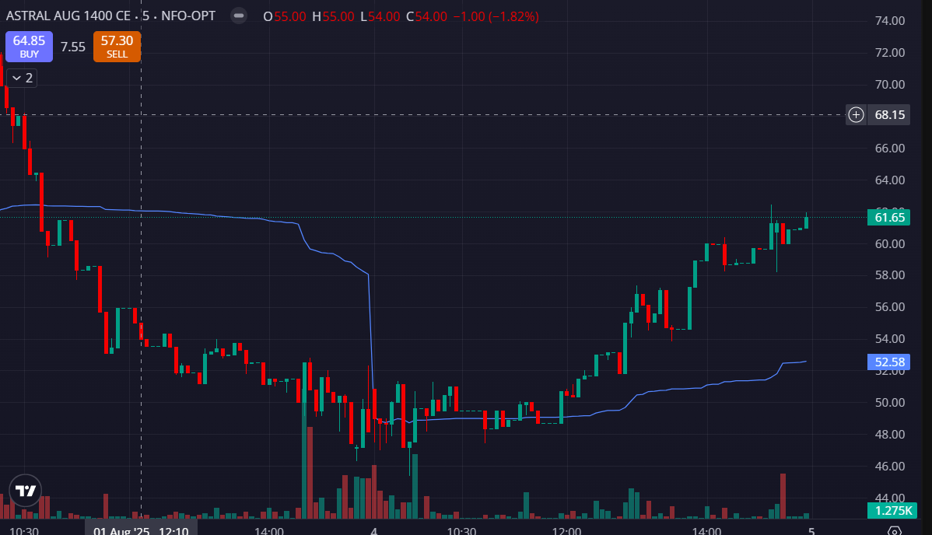
- PRICE OPENED GAP DOWN
- VOLUMES GREEN SIDE AFTER 12:00
- PRICE ABOVE THE VWAP AFTER 12:00

