WIPRO 250 CE
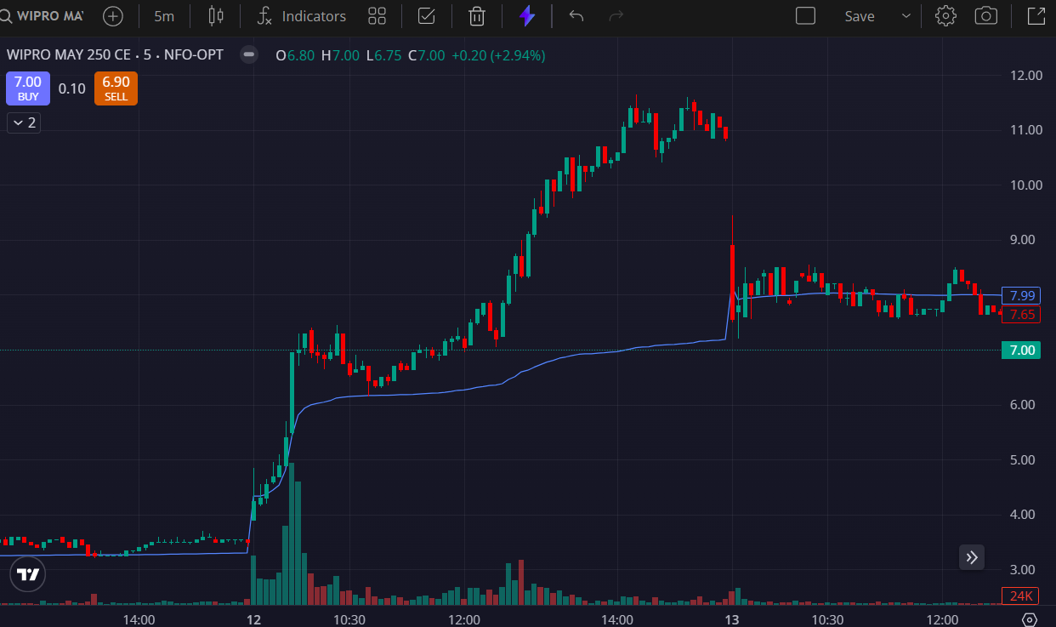
- PRICE OPENED GAP UP
- PRICE ABOVE THE VWAP
- VOLUMES GREEN SIDE

