PIIND 3700CE
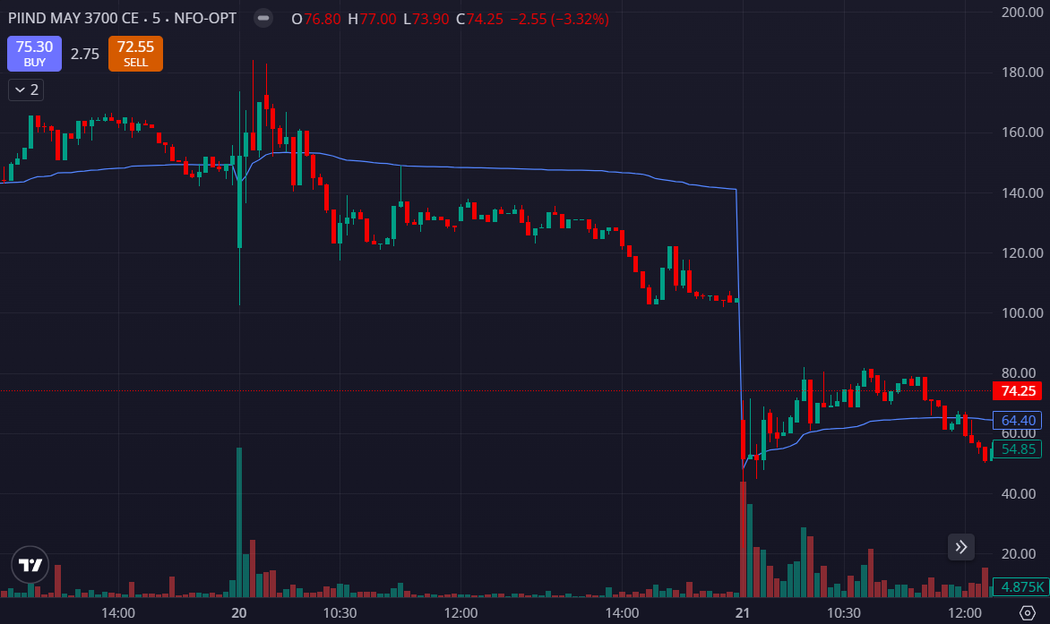
- PRICE OPENED GAP UP
- PRICE BREAK LAST MONTH HIGH
- PRICE BELOW THE VWAP

