OIL 430CE
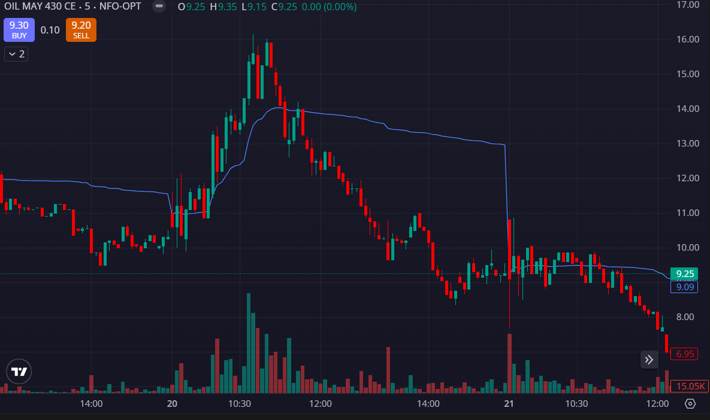
- VOLUMES RED SIDE
- PRICE REJECTED VWAP

