LTF 170CE
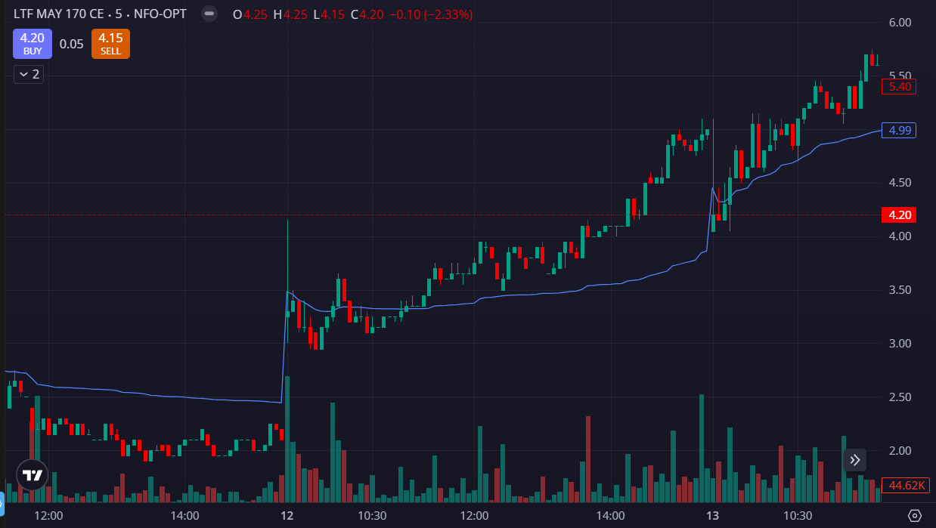
- PRICE OPENED GAP UP
- TRADED ABOVE VWAP
- VOLUMES GREEN SIDE

