KALYANKJIL 540CE
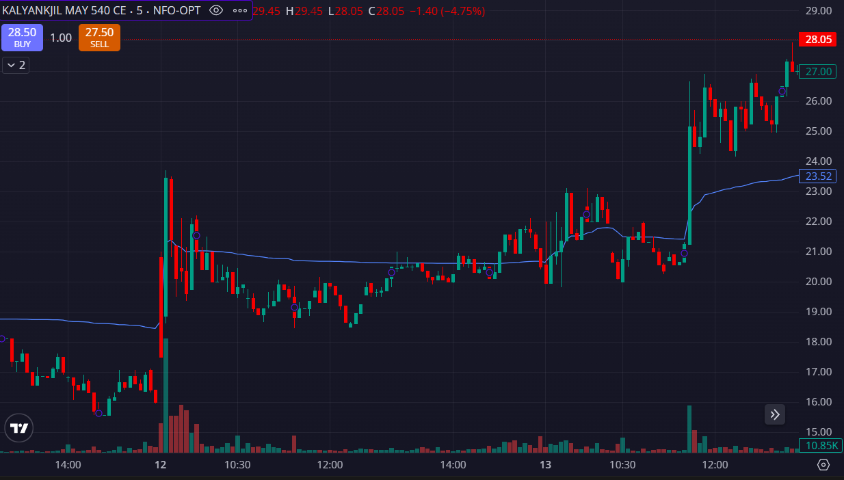
- PRICE BELOW THE VWAP
- LESS VOLUMES

