HINDALCO 650CE
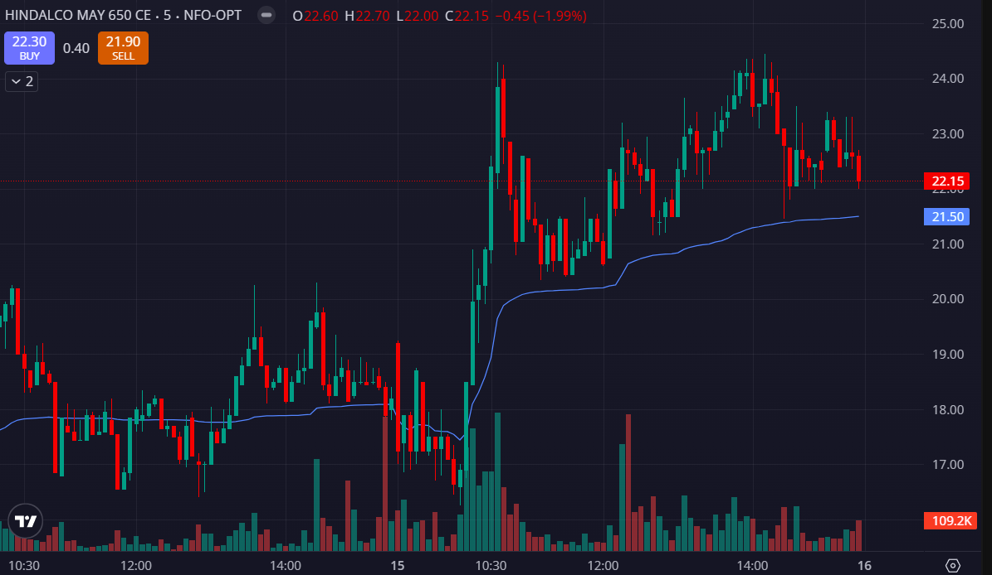
- VOLUMES GREEN SIDE
- PRICE ABOVE THE VWAP

