HDFCAMC 4500CE
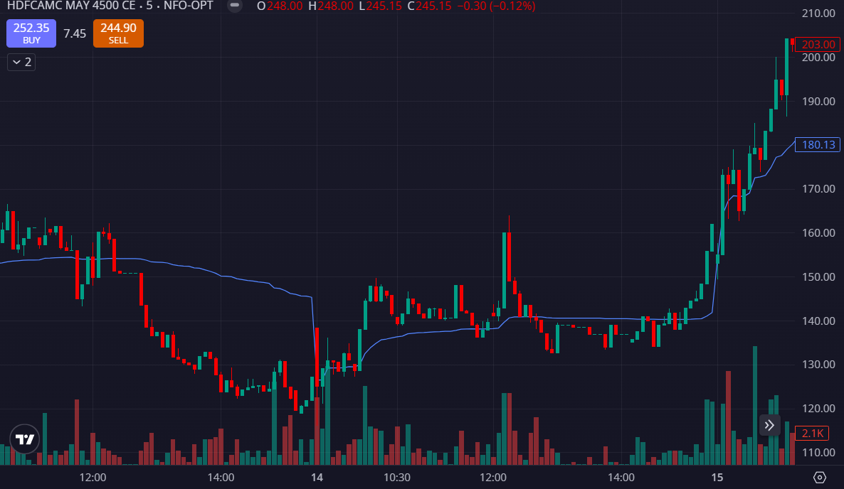
- VOLUMES GREEN SIDE
- PRICE BOUNCED BACK FROM AORUND 120-125 MULTIPAL TIMES

