HCLTECH 1660CE
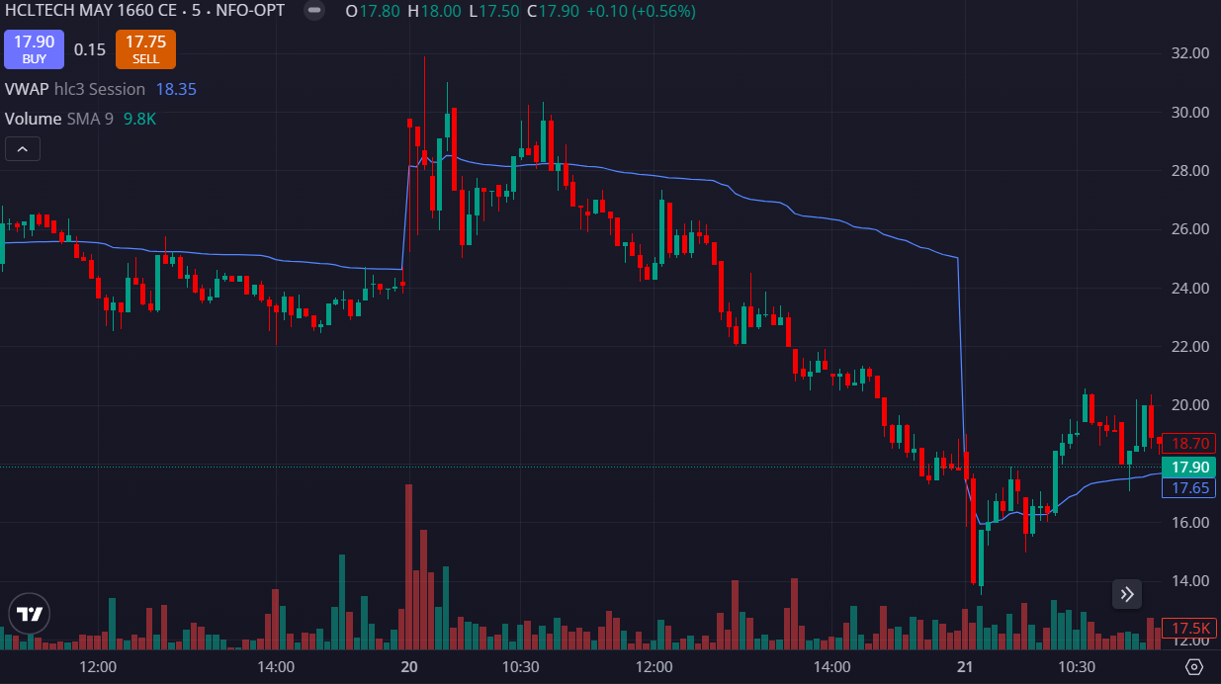
- PRICE OPENED GAP DOWN
- PRICE REJECTED VWAP
- PRICE BELOW THE VWAP

