HAL 4700 CE
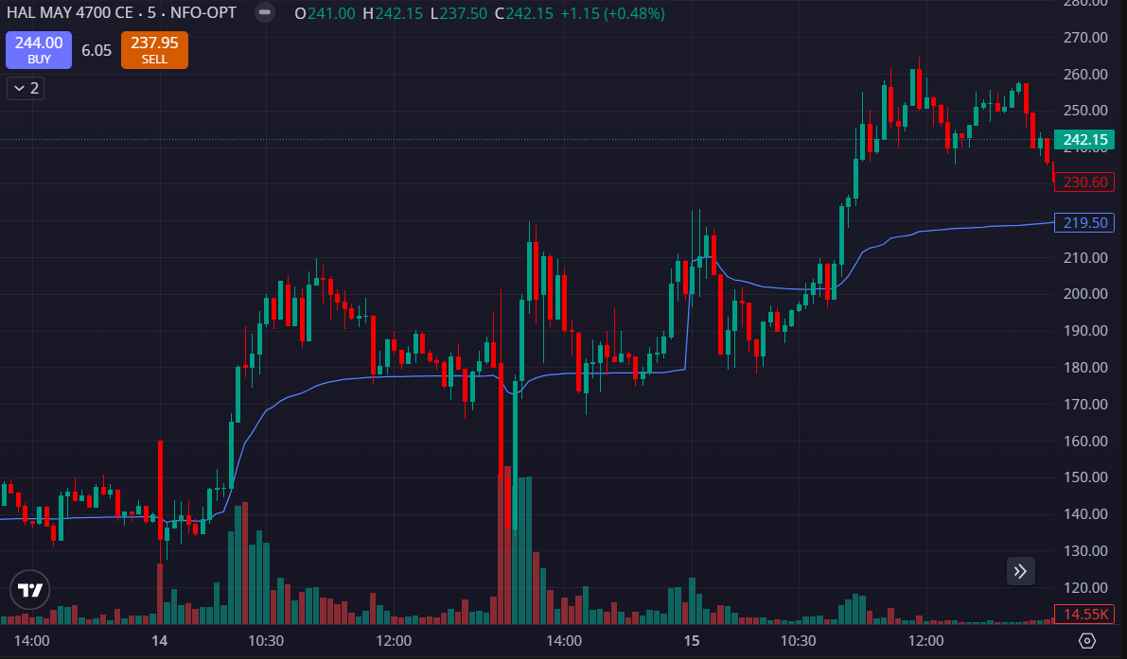
- TRADE ABOVE THE VWAP
- PRICE HAD BOUNCED BACK FROM 160-170

