GODREJCP MAY FUT
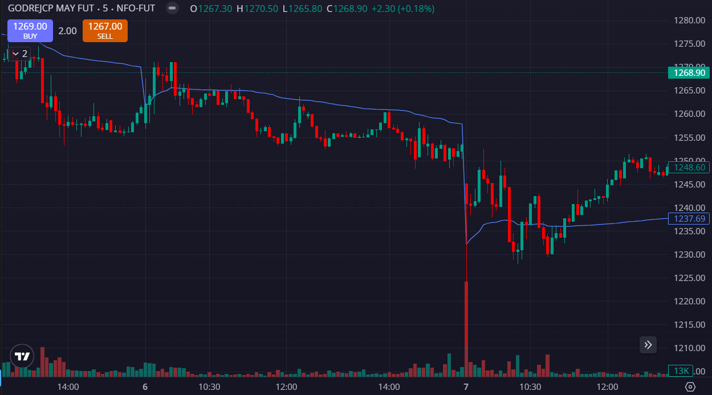
- LESS VOLUMES
- PRICE BELOW THE VWAP

