ETERNAL 235CE
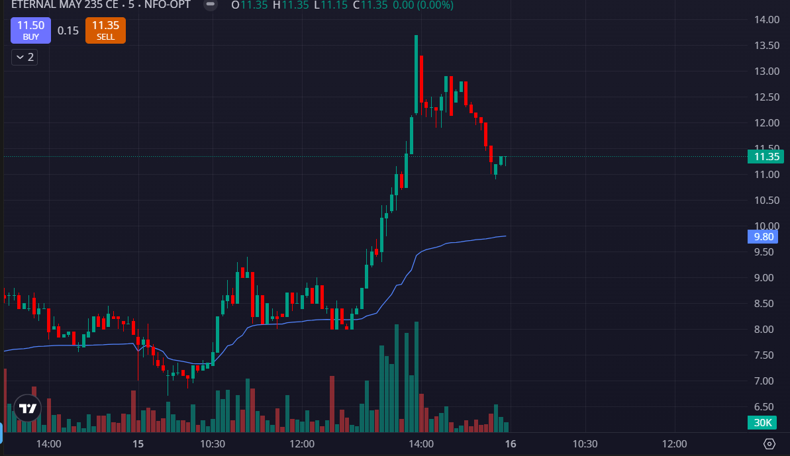
- VOLUMES GREEN SIDE
- PRICE ABOVE THE VWAP
- PRICE MADE LAST TWO DAYS HIGH

