BANKBARODA 235CE
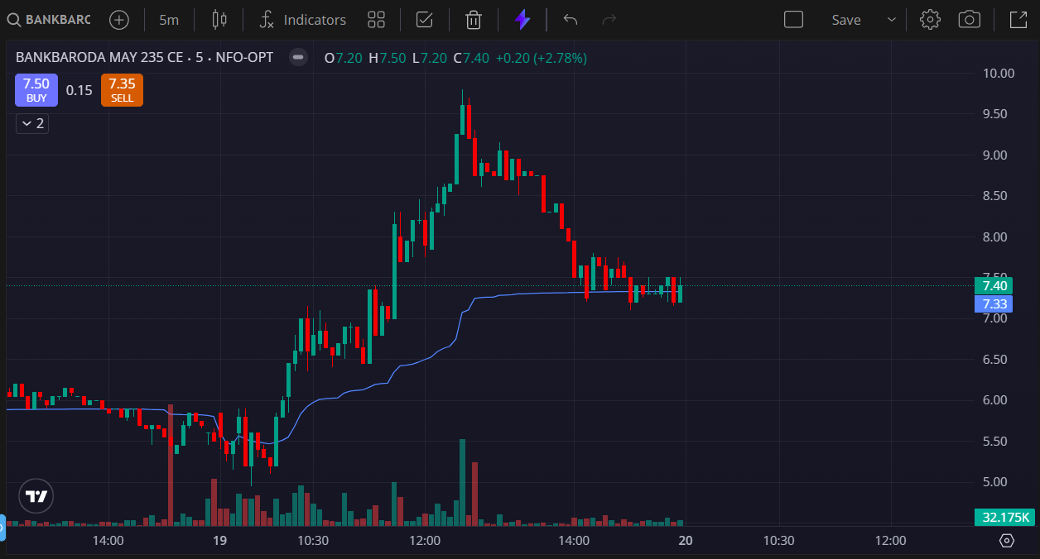
- PRICE ABOVE THE VWAP
- VOLUMES GREEN SIDE
- PRICE MADE LAST TWO DAYS HIGH

