ASTRAL 1340CE
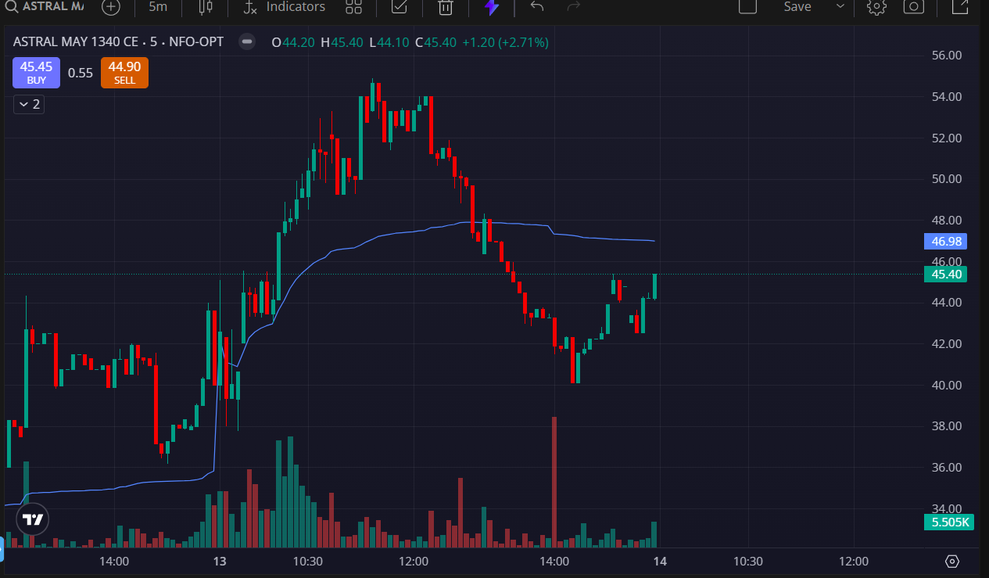
- PRICE OPENED GAP UP
- TRADED ABOVE VWAP

