TRENT 4800 CE
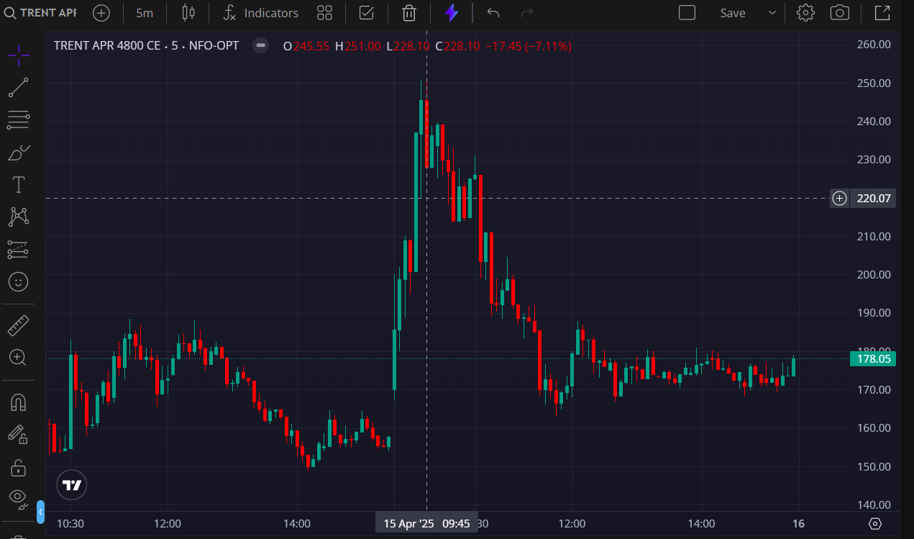
- BOOKED 2ND TGT @250

