POONAWALLA 295CE
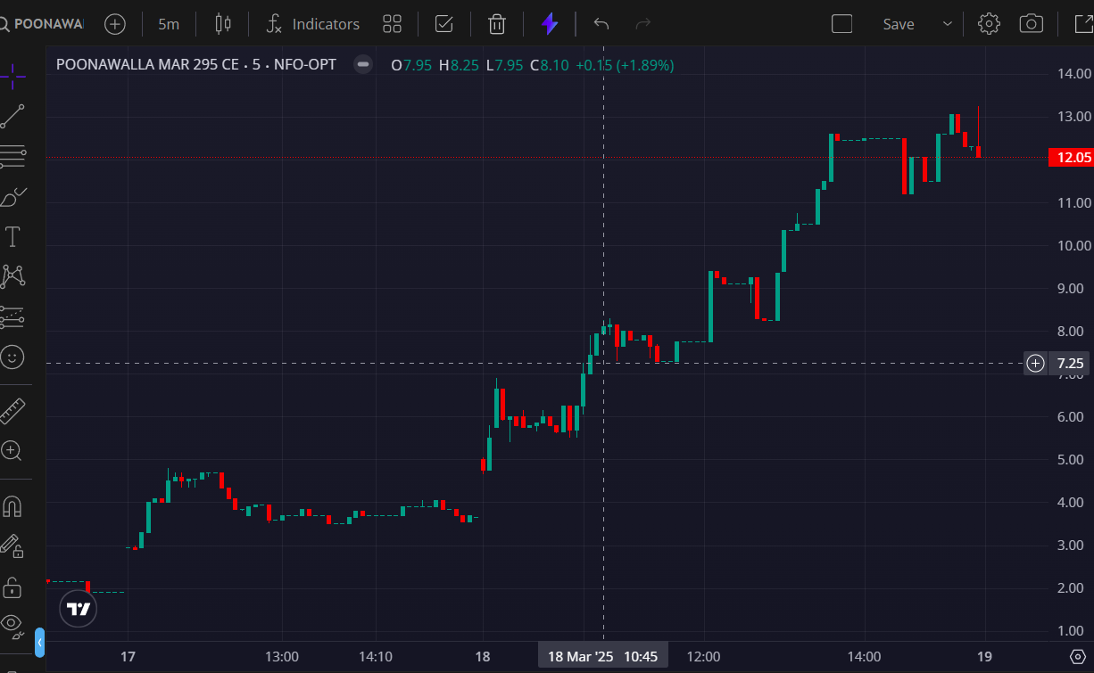
- BOOKED 3RD TGT @8

