APOLLOTYRE 410CE
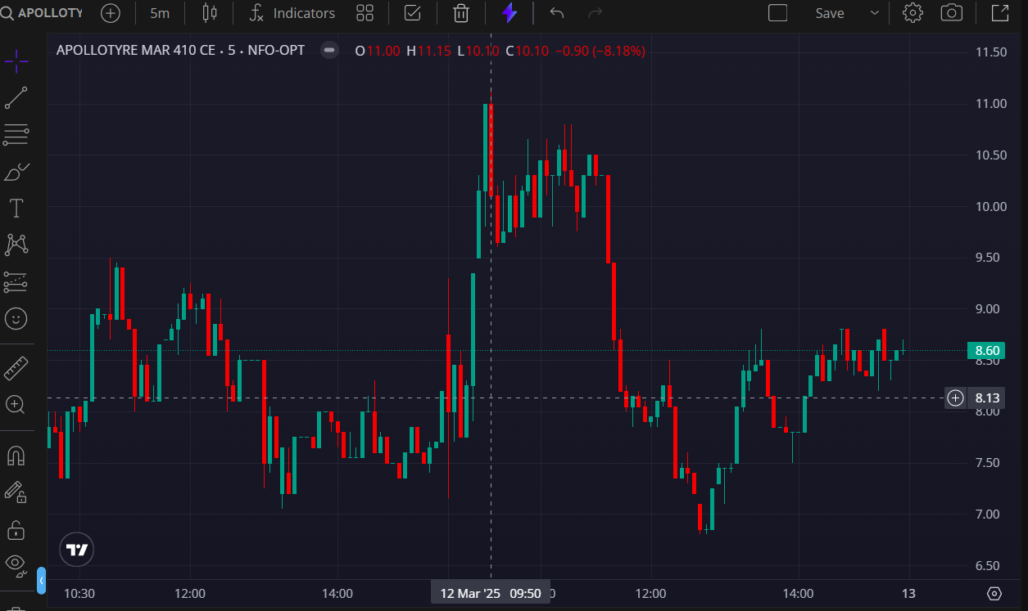
- BOOKED 1ST TGT @11

