ALKEM 4800CE
{BTST}
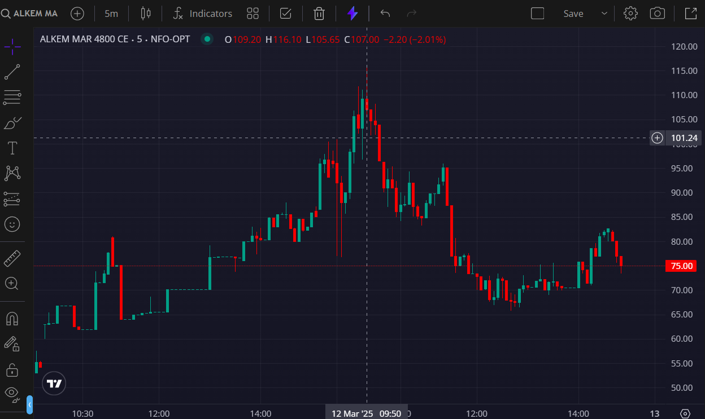
- BOOKED 1ST TGT @115

