ABB 5400 CE
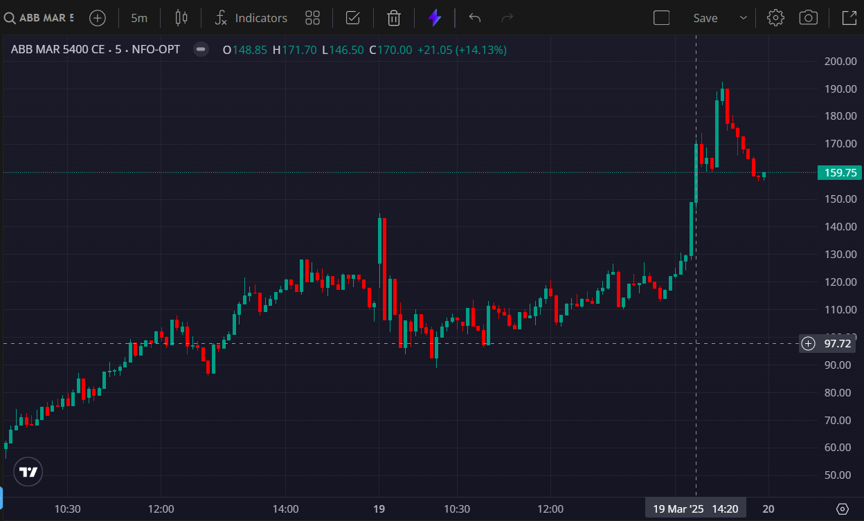
- BOOKED 1ST TGT @150

