DIVISLAB 5550CE
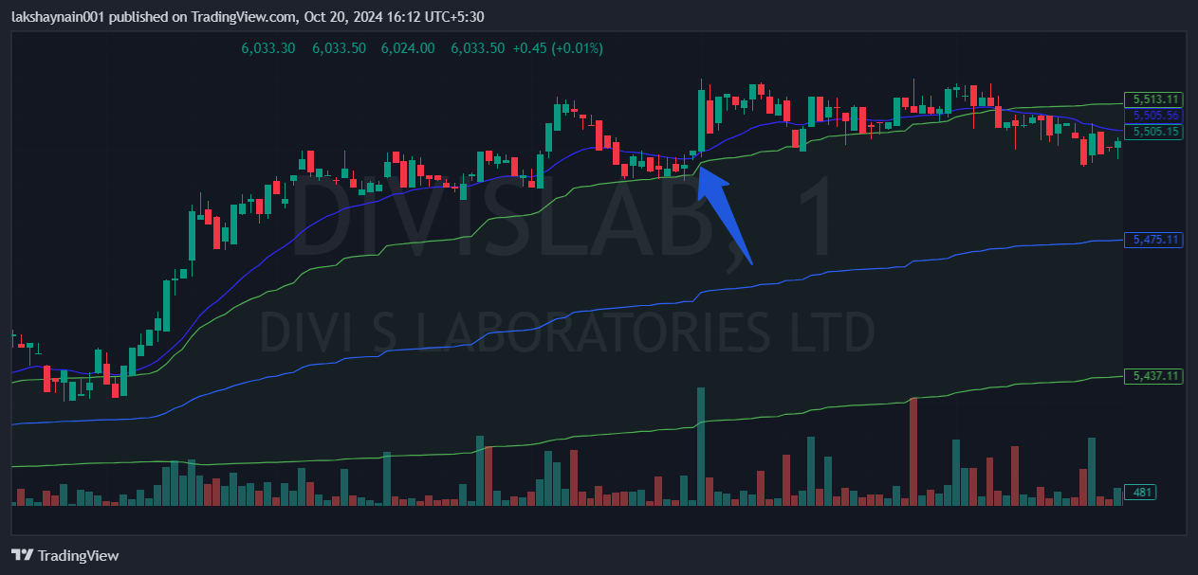
- Price opened gap up
- Nifty pharma index on move
- Price trading above vwap and 20EMA

