APOLLOHOSPTALS 7050CE
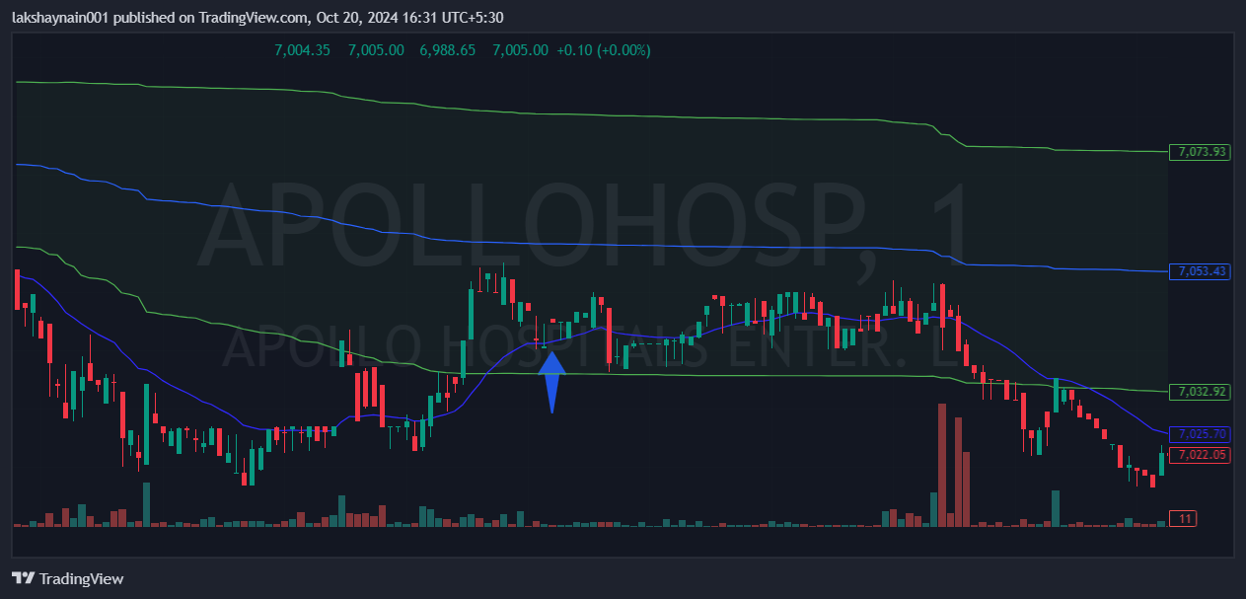
- Breaks 20EMA resistance
- Trading near vwap
- SL hit below vwap

