MCX 6400PE
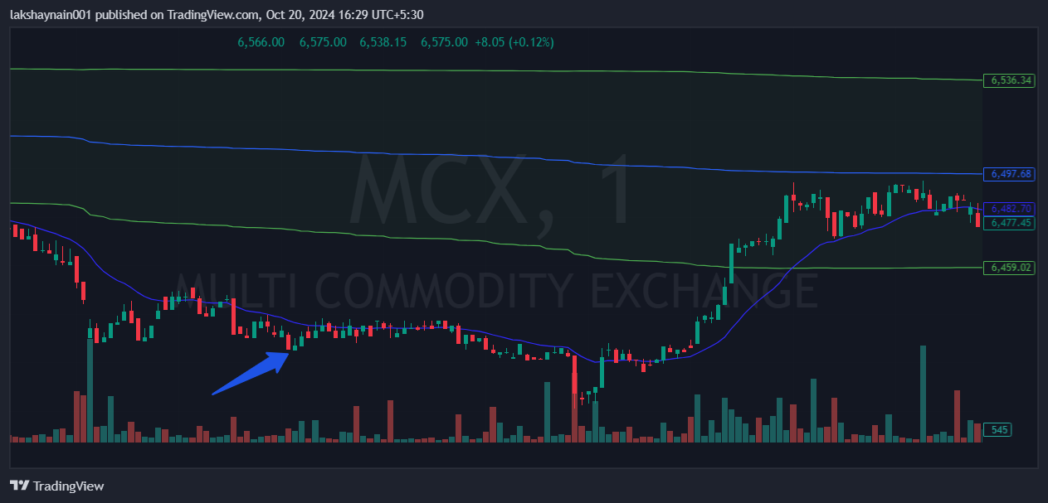
- Price opened gap down
- Breaks day low belo 20EMA
- Trading below vwap
- Sl hit above vwap

