OFSS 12000CE
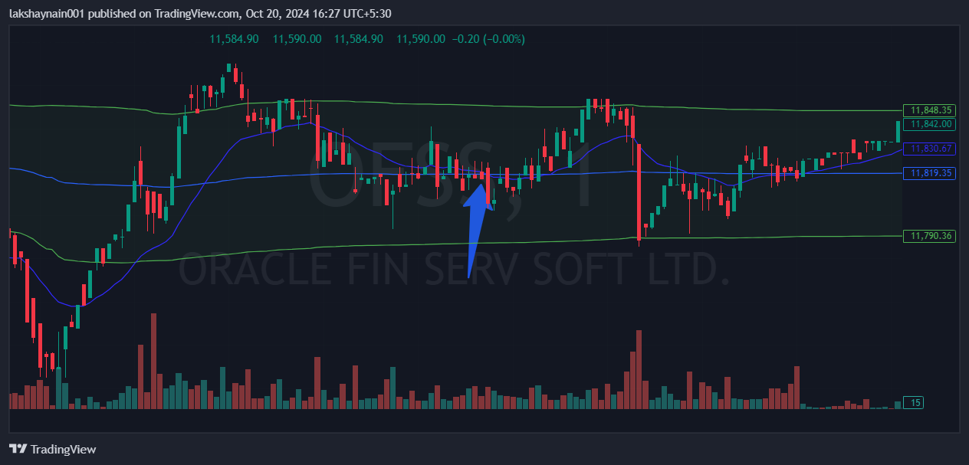
- Trading at vwap and 20EMA
- Sl hit below vwap lower band

