BAJAJFINSV 1900CE
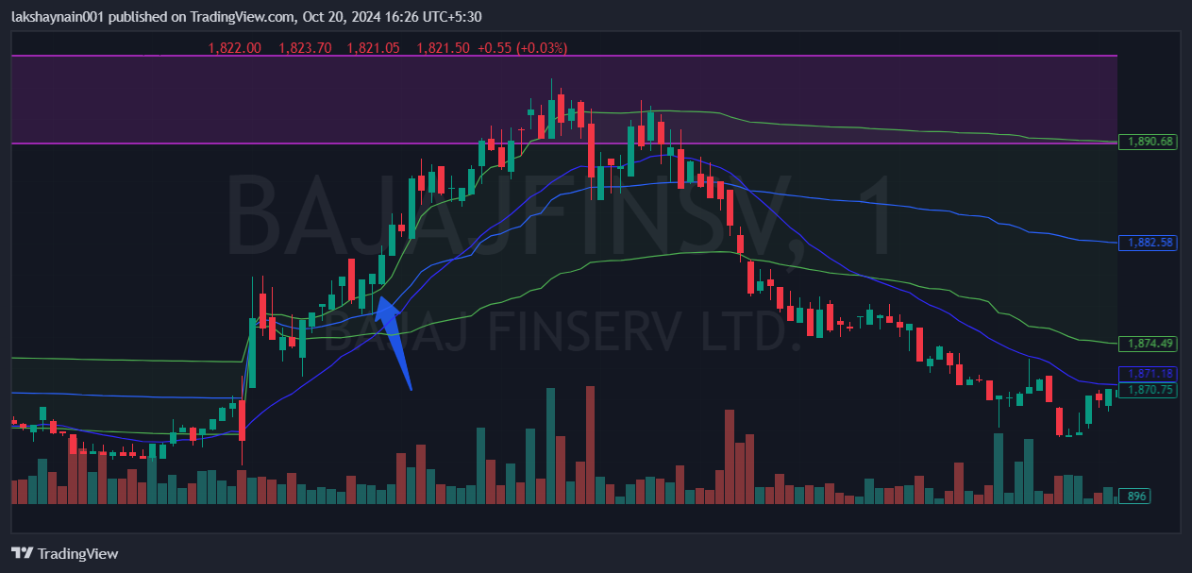
- Price got support at 20EMA
- Trading above vwap
- SL hit below vwap

