AUROPHARMA 1280CE
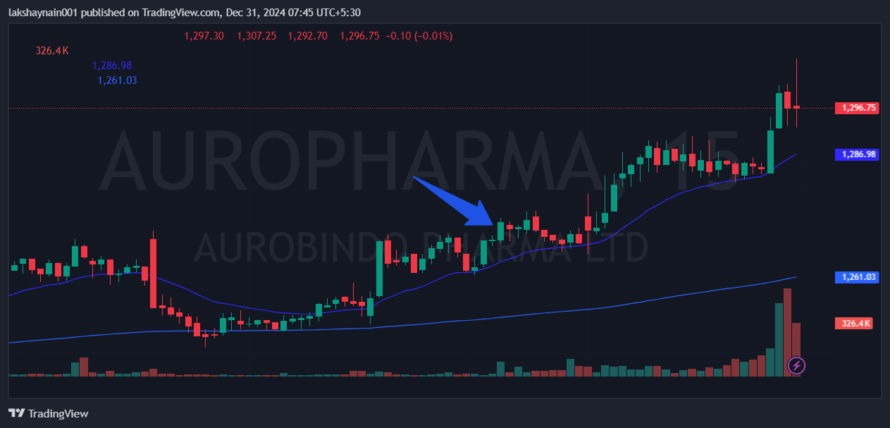
- Price broke last two days high
- Trading above 20 and 200EMAs
- Nifty pharma on move

