HAL 4500CE
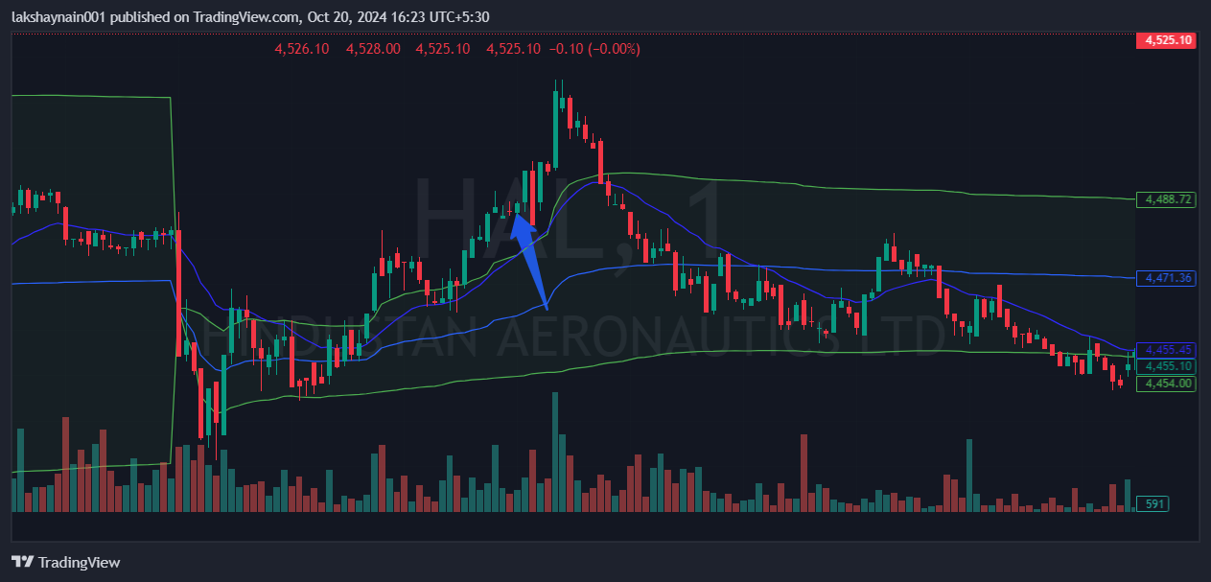
- Price breaks previous day high
- Got thrust from 20EMA
- Trading above vwap

