AUBANK JAN 550CE
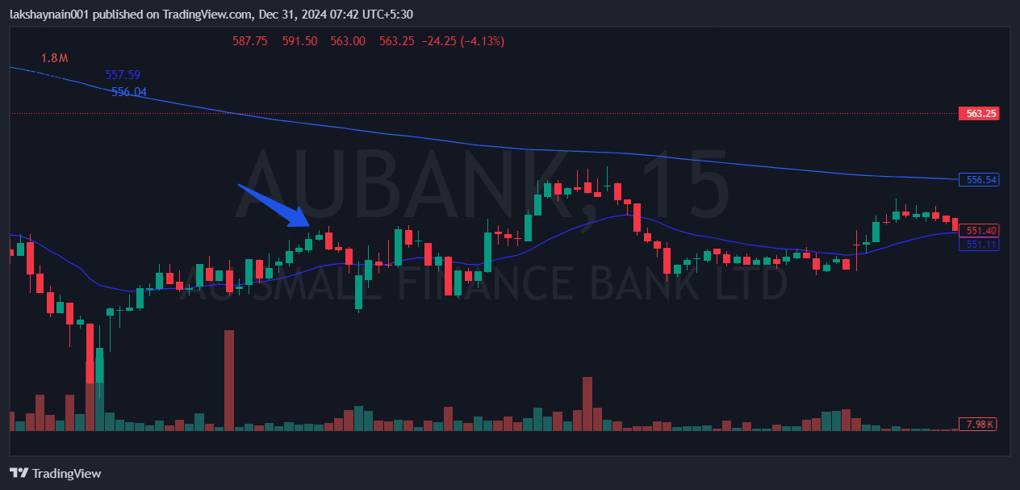
- BROKE TWO DAYS HIGH
- Trading with 20EMA support

