HEROZERO SUNPHARMA 1820CE

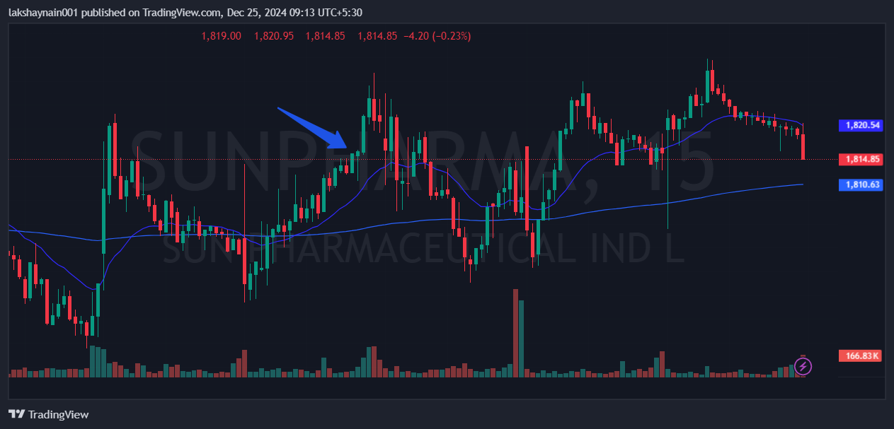
- Price broke day high
- Trading above 20EMA
- Golden crossover in 15min tf

