BHEL 250CE
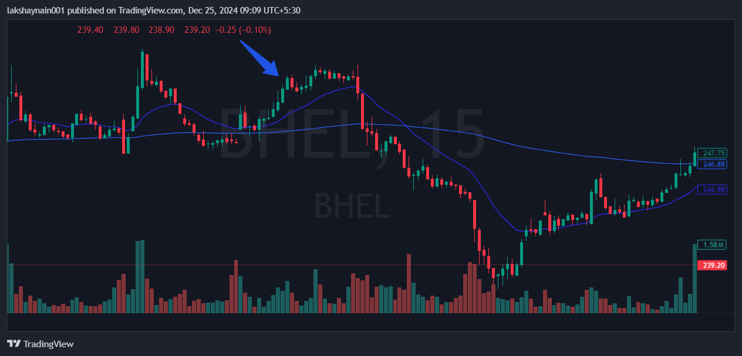
- Broke day high with good volumes
- Resisted deathcrossover multiple times
- Sl hit with death crossover

