HINDALCO 680CE
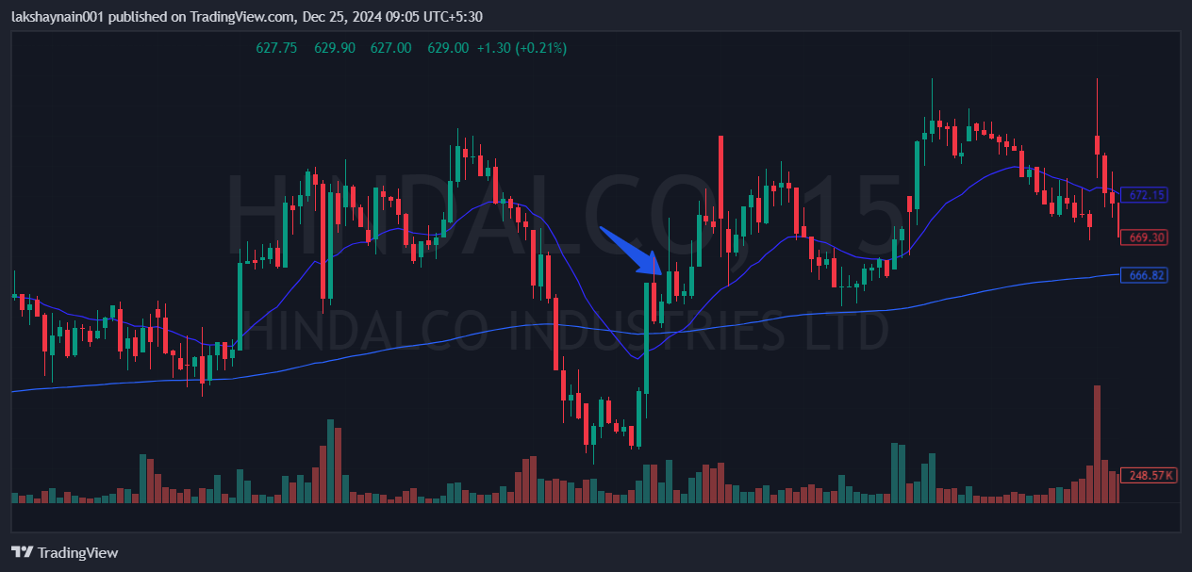
- Golden crossover 15min TF
- Broke day high with bullish candle
- Got reaction from both EMAs

