PNB 110CE
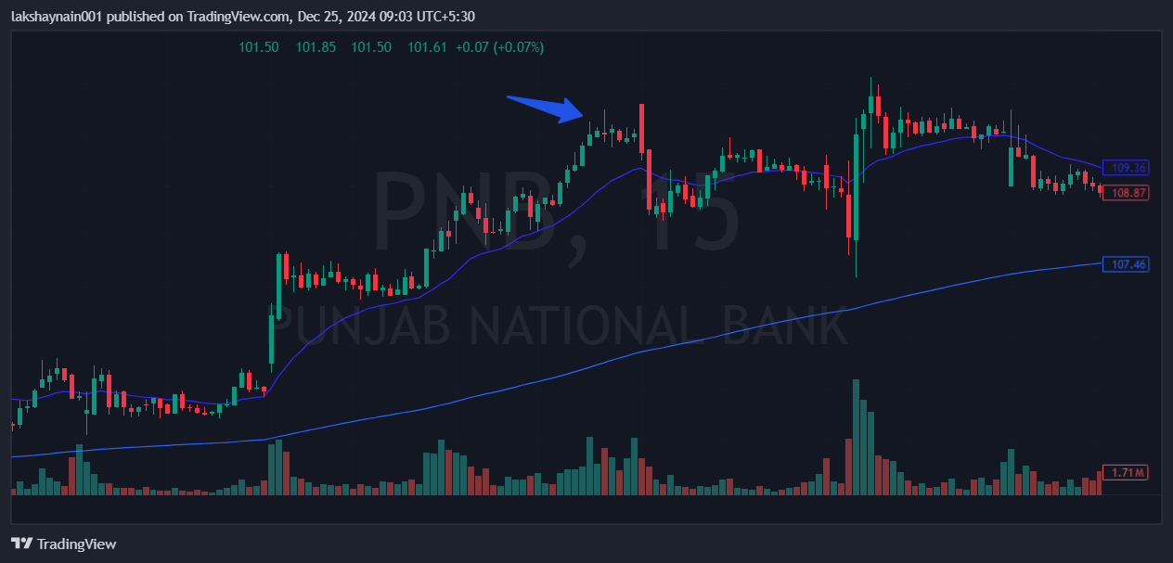
- Banknifty on move
- Trading with nice 20EMA support
- Sl hit below 20EMA (clbs)

