INDUSTOWER 350CE
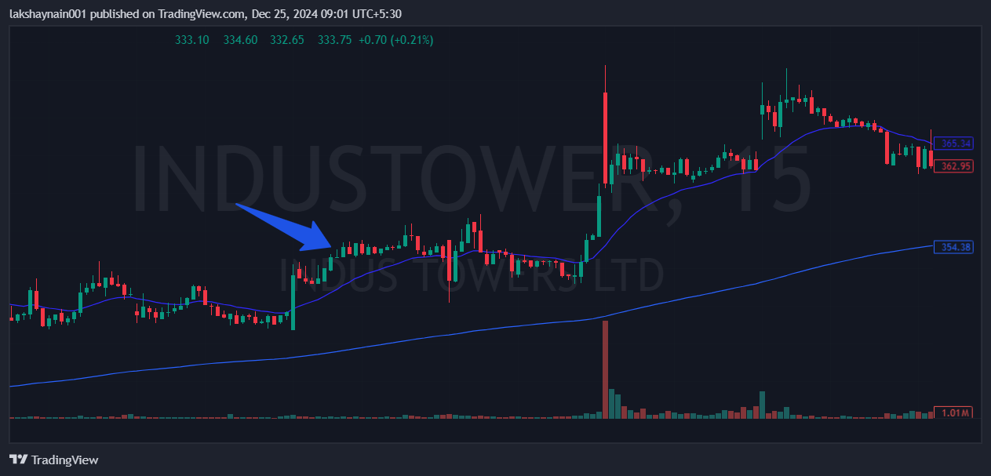
- Price broke previous day high
- Trading above 20EMA
- Range breakout

