PETRONET 330CE
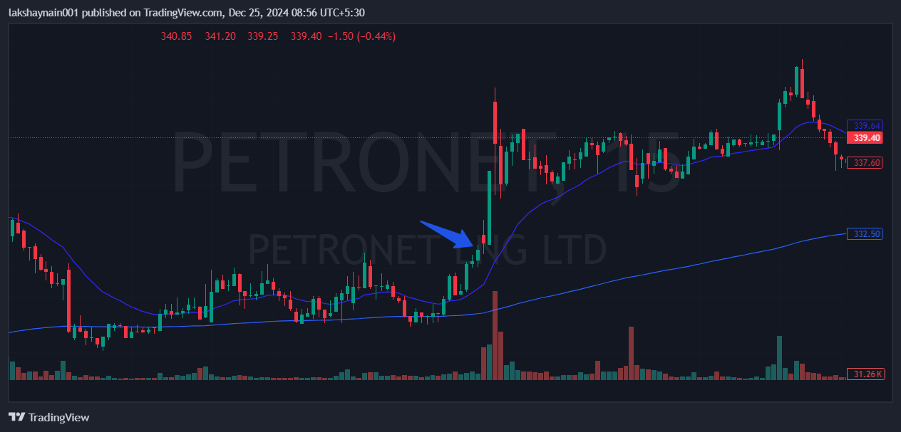
- Price broke previous 2 days high
- Trading at 20 and 200EMA
- Avoided death crossover twice

