DIVISLAB 5900CE
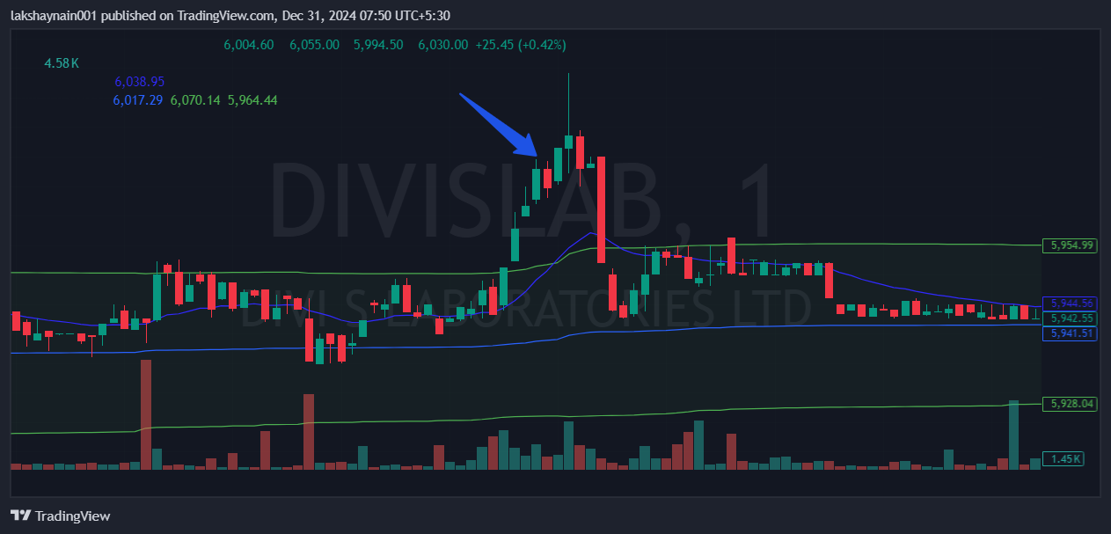
- NIFTY pharma on move
- Price broke day high with good volumes
- Trading above vwap and 20EMA

