BALKRISIND 2900CE 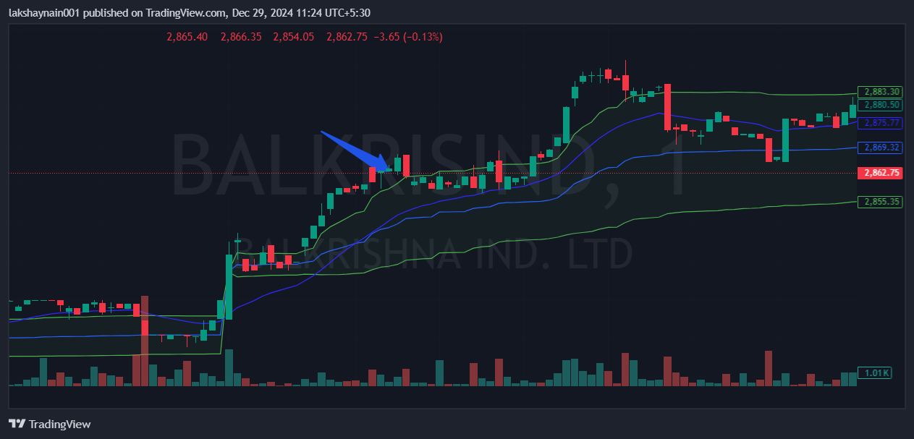
- Price break day high
- Trading above 20EMA
- Trading above vwap

