BAJAJAUTO JAN 8900CE
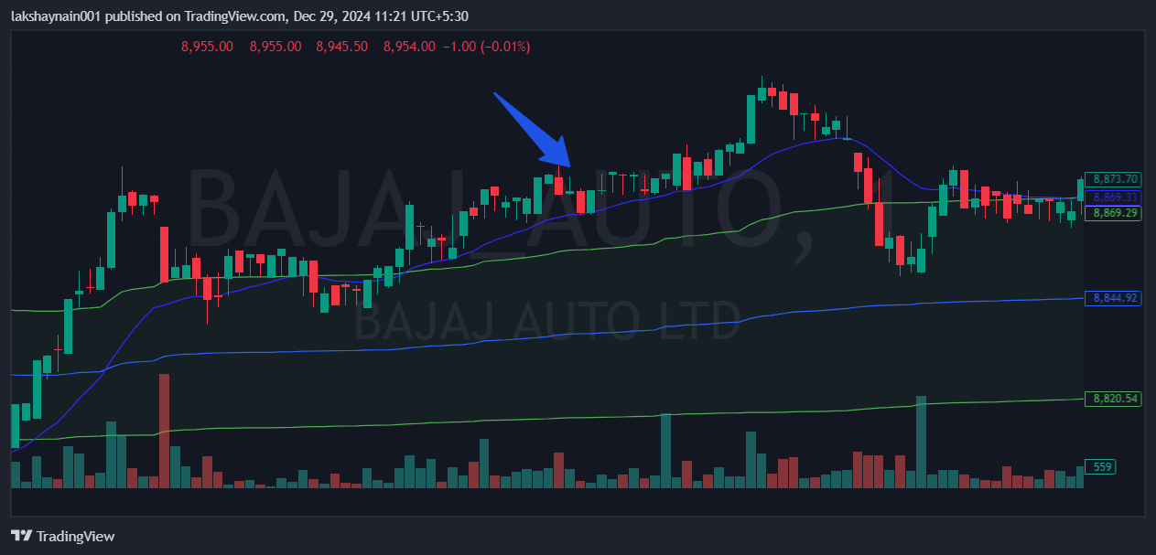
- Price trading with 20EMA support
- Trading above vwap

