PVRINOX 1600CE
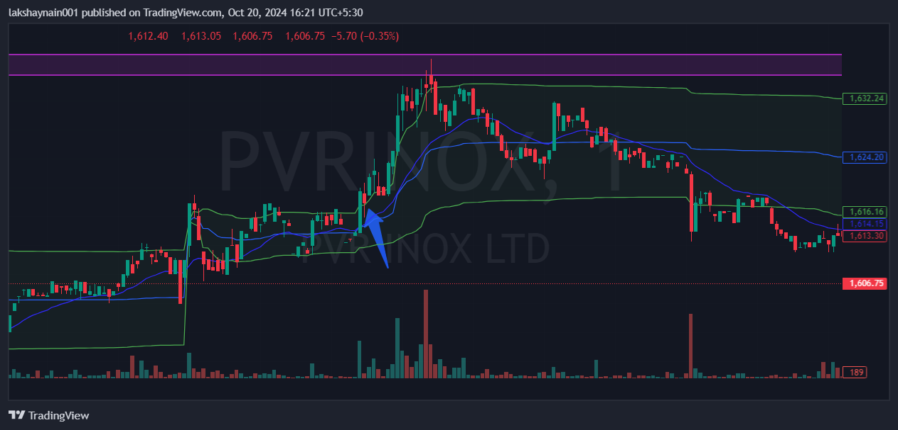
- Price opened gap up
- Breaks dayhigh with volumes
- Trading above 20EMA and vwap

