BTST HFCL JAN 120CE

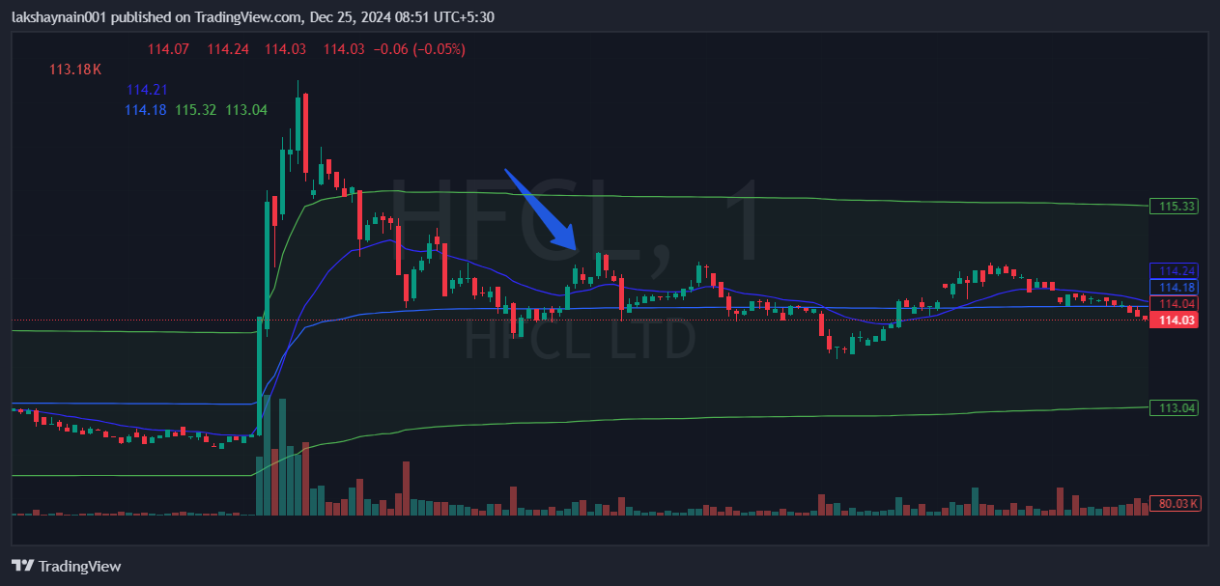
- Price gave good move with volumes
- Trading with 20EMA
- Above vwap

