MGL JAN 1260CE
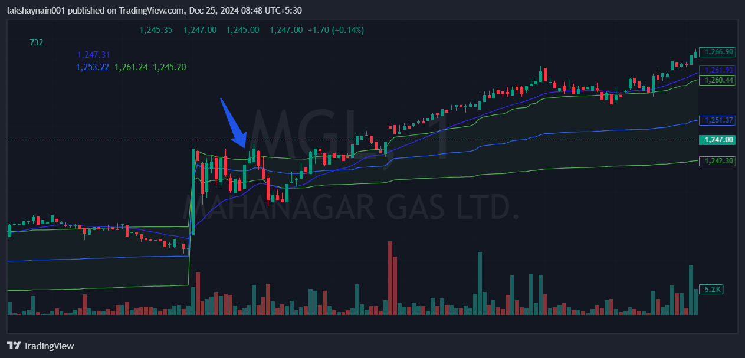
- Price bounced from 20EMA in the very first candle
- Trading with vwap support

