ITC 470CE
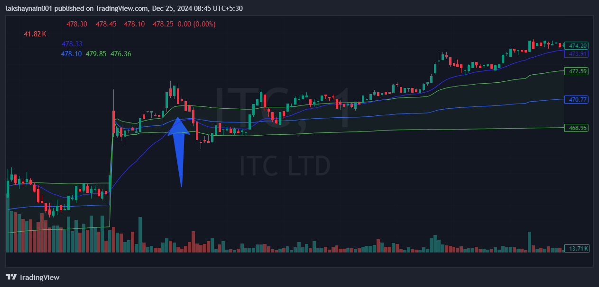
- Price opened gap up
- Trading with 20EMA support
- Trading above vwap

