ATUL 7400CE
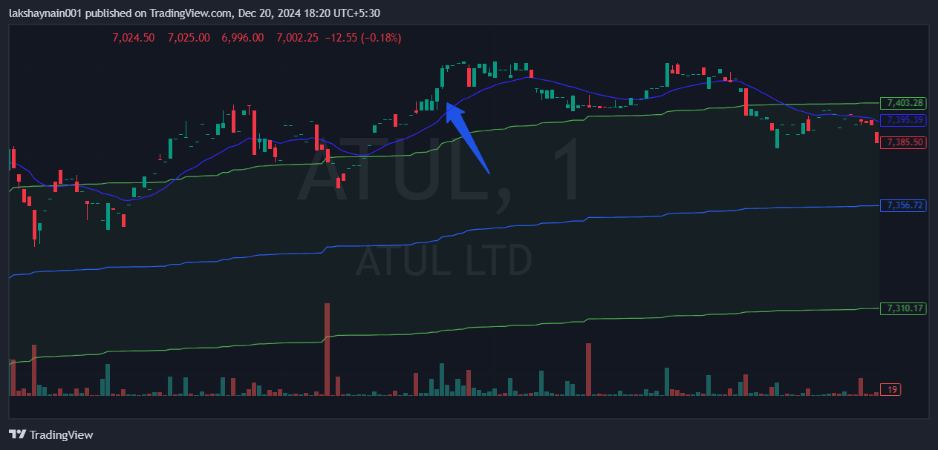
- Price broke day high
- Trading above 20EMA and vwap
- Sl hit below vwap

