TORTPHARM 3400CE
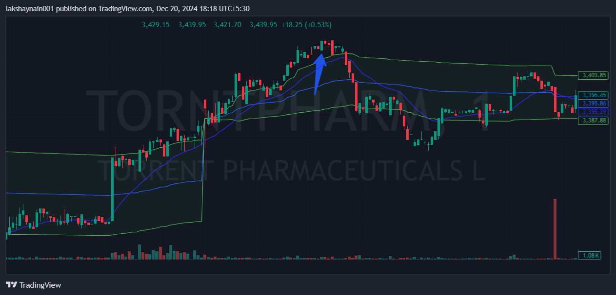
- Price broke day high above 20ema
- Price trading above vwap
- Sl hit below vwap

