NYKAA 175CE
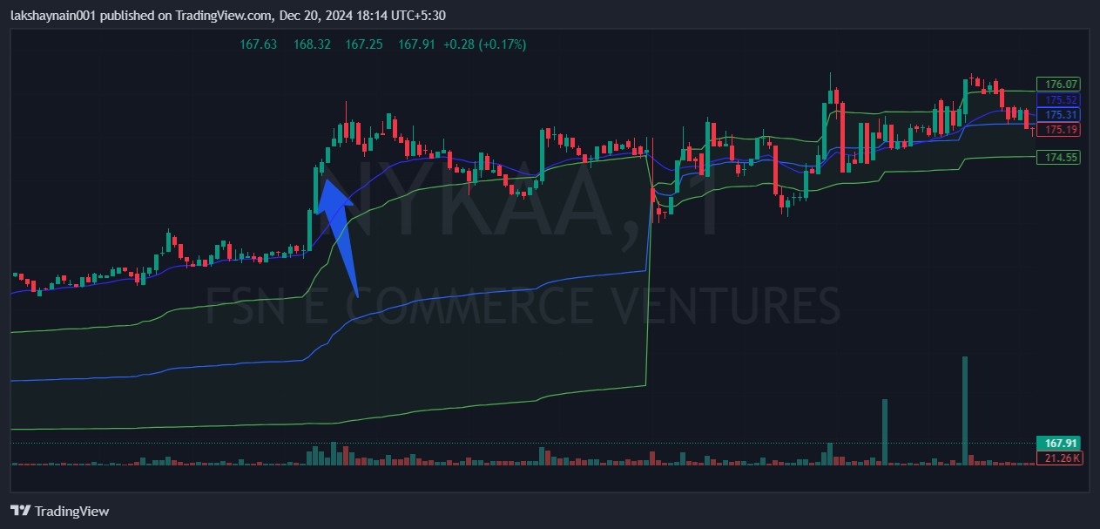
- Price broke day high with volumes
- Got thrust from 20EMA
- Trading above vwap

