ADANIENSOL 820CE
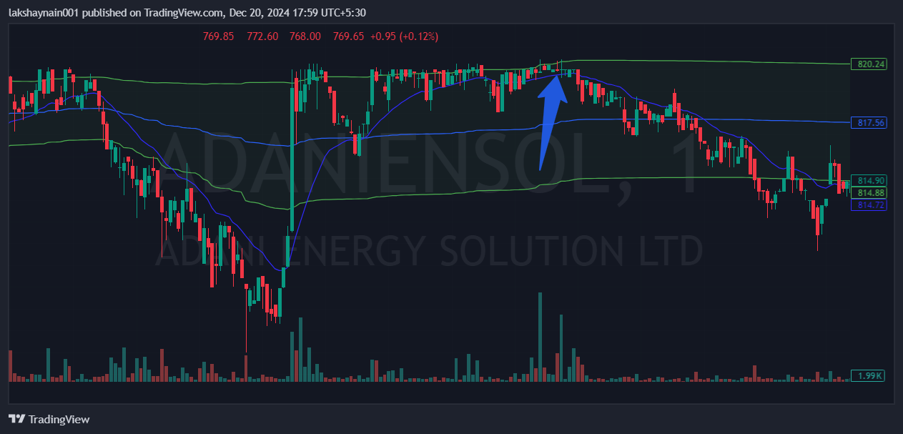
- Price broke day high
- Trading in a range above 20EMA
- Sl hit below vwap

