TATA STEEL 152.5CE
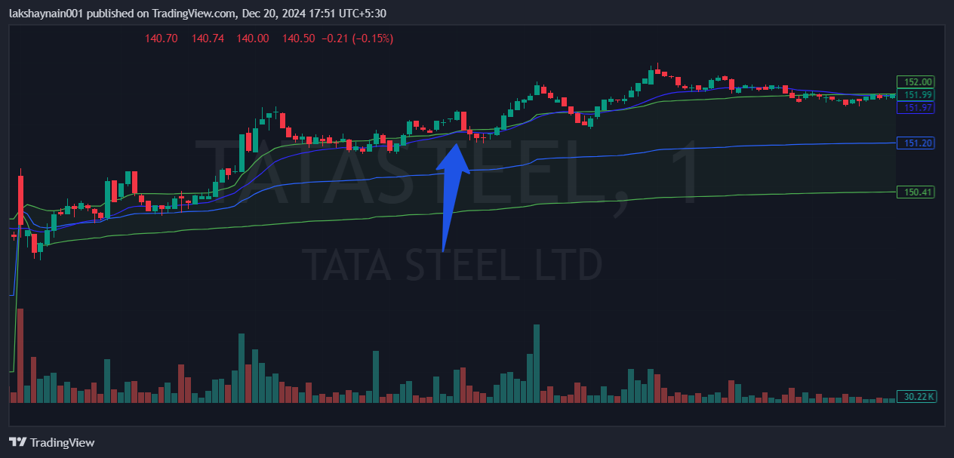
- Trading with 20EMA support
- Trading above vwap
- Sl hit below vwap

