HAL 4500CE
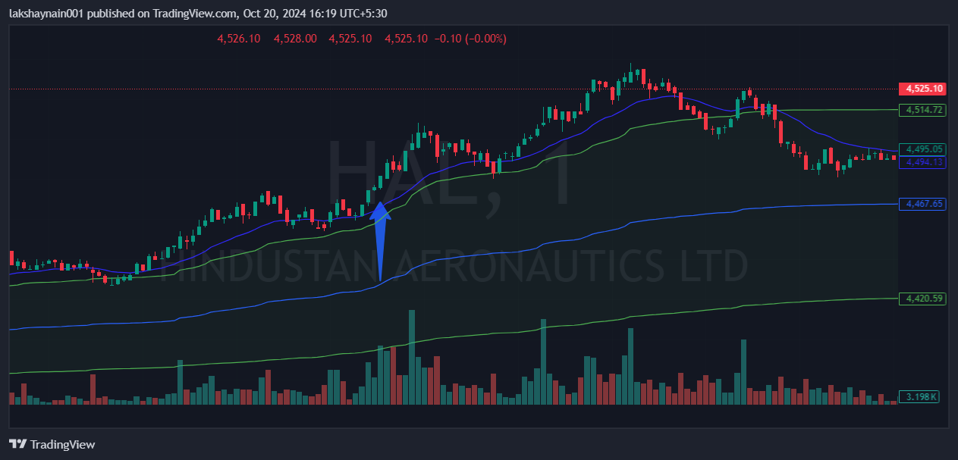
- Price breaks day high
- Trading with 20EMA strong support
- Trading above vwap

