09.12.24
HINDCOPPER 300CE
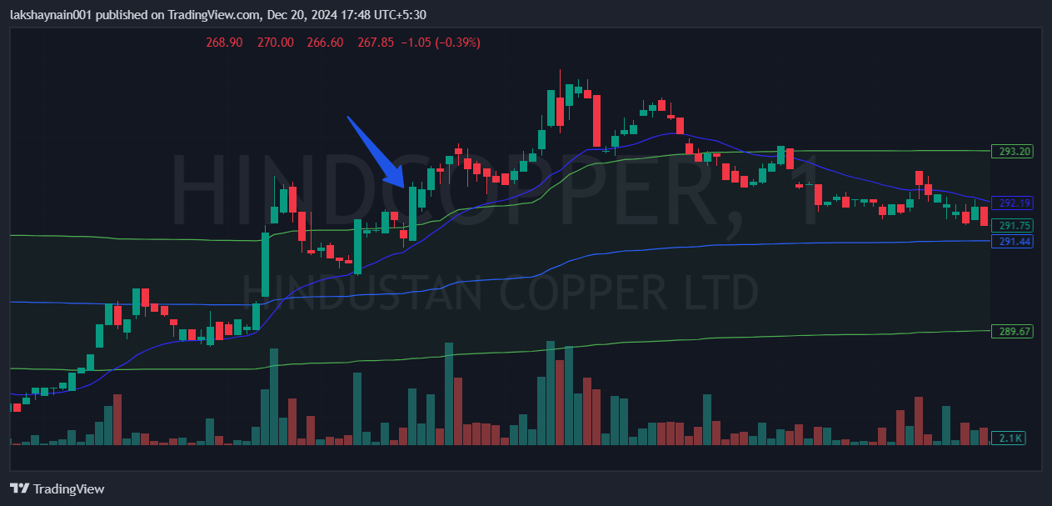
- Price broke day high with good volumes
- Got thrust from 20EMA

