ACC 2260CE ABOVE 63
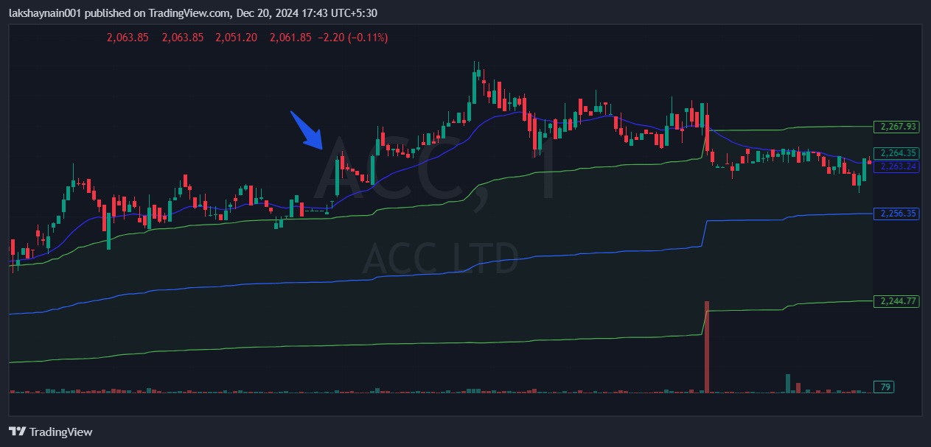
- Price broke day high with bullish candle
- Trading with 20EMA support
- Trading above vwap

