BOSCHTLTD 35000CE

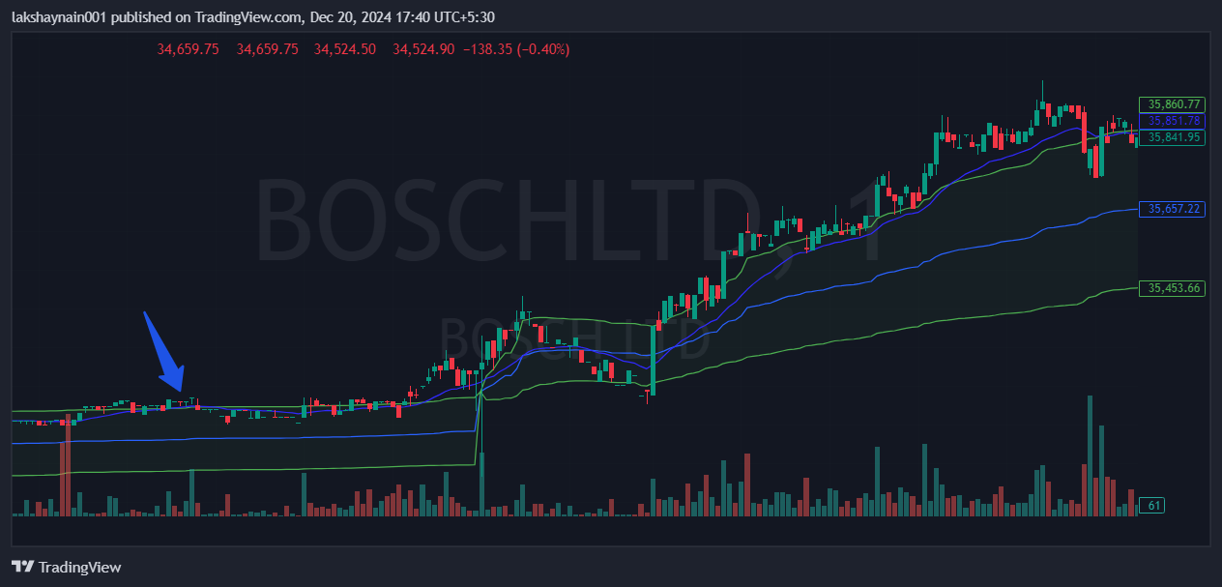
- High green volume’
- Trading with 20EMA support
- Traging above vwap

