INDUSTOWER 350CE
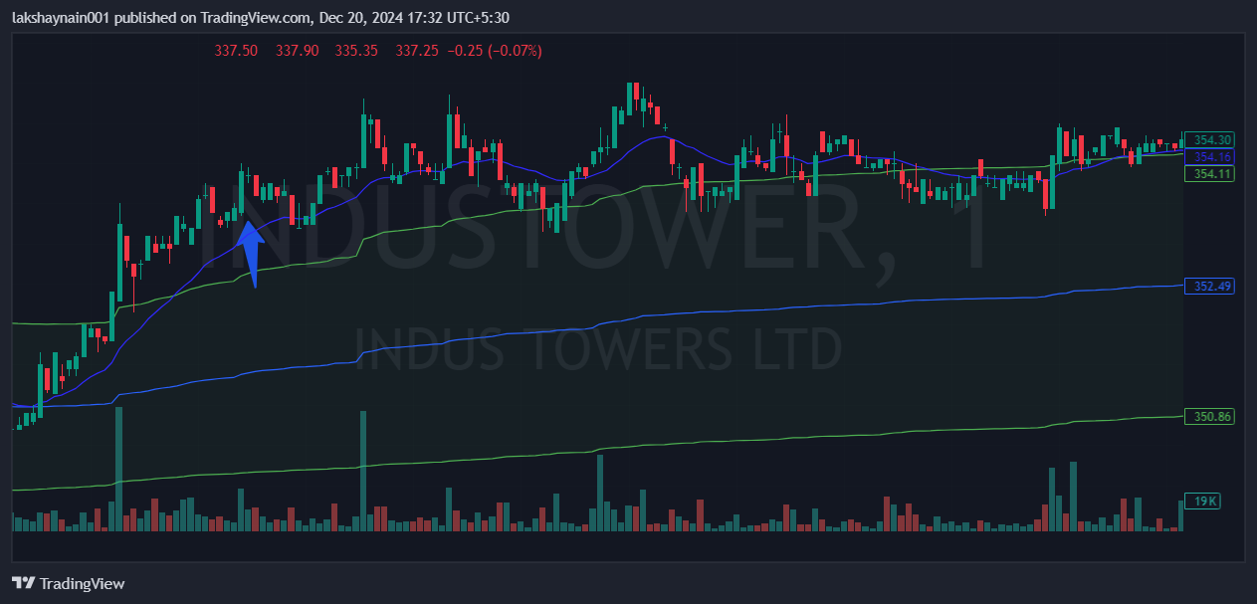
- Price broke day high
- Big bullish engulfing formed
- Trading above vwap and 20EMA

